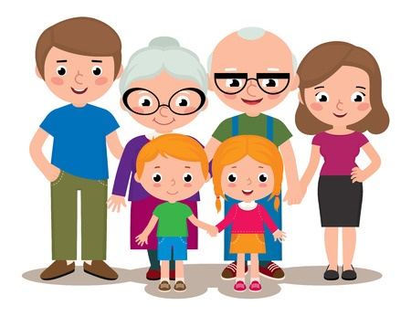**DIE FAMILIE**

**DER OPA**

**DIE MUTTER**

**DIE OMA**

**DIE SCHWESTER- siostra**

**DER BRUDER - brat**

**DER VATER**